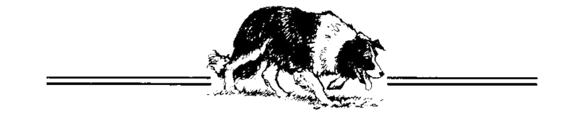

Ontario Border Collie Club
Annual General Meeting
PROXY

I ____________________________________________ , as a member in good standing,

appoint ________________________________________________ as my proxy for the
Ontario Border Collie Club Annual General Meeting.

Signature of Member _________________________________________

Date _____________________

To vote by proxy, a member of the OBCC must complete this form and provide it to the Chair of the AGM prior to the beginning of the meeting. It can be submitted on the date of the meeting or sent in advance to:

secretaryobcc@gmail.com

