OBCC Board Meeting Minutes

January 24, 2018 7:00pm

Attendees:
Kim Gretton
Tracy Hinton
Rebecca Lawrence
Cynthia Palmer
Werner Reitboeck

Agenda:
• Approval of the minutes from last board meeting
• Review TO DO’s from last meeting
- Confirm were we are at on the To Dos
- Learning and Outreach discussion to be added
- Membership costs to be be added
• Treasurer report and budget
• Other

Minutes Approval
- Review December 5, 2017 minutes. Rebecca approved, Werner second
- TO DO- Rebecca to Post on website

Committees:
- Newsletter
  - Cynthia spoke with Helen Dunning & Kris Kiviaho
    - TO DO –
      - Cynthia to send out reminder email regarding the newsletter deadline
      - Schedule a meeting of board and newsletter team to discuss next
      - Tracy pointed out that the Board needs to work on this newsletter so that the rest of the year flows easily
- Fundraising
  - Pamela Hall
  - Janet Fahey
  - Rebecca spoke with Michelle Taliana re: joining the committee & provided her with Pam’s contact information
  - TO DO –
    - Agree on the vector file of the logo. The Board has agreed that we do not need to contact Mia as long as the vector file for the embroidery is close to our logo & is consistent (none of the previous distortions over the year
    - Colours used should be documented so that going forward, anyone who steps in to the position does not have to repeat the work
- Learning & Outreach
  - Cynthia spoke with Sue Jewell re: hosting a small Novice trial at her farm for the beginning of the trial year
  - Discussion regarding ideas of what can the Board do for Learning & Outreach at this trial
    - Werner brought up the idea of judging outloud during a fun run, or as a mentor to help handler with a suggestions during the run like as a training session.
    - He is concerned that the Novice handlers are fixating on the minute elements of a run, not on the run as a whole: a team moving the sheep efficiently with a minimum of stress from setout to the pen via some elements.
    - Should be aiming to be a better handler, not to fixate only on the points
  - The board needs to decide how we want to run this event, as a one day with AM Fun Runs & PM Trial or as a 2 day event with 1st day Fun Runs & 2nd Day Trial (or vice versa
  - Cynthia to speak with Sue to see if she would be amenable to hosting such an event
    - TO DO –
      - The Board needs to decide were we can run the trial & where to do the judging day
- Trials Committee
  - Tracy sent out an email to the members and they had an email meeting regarding the area trial guidelines
  - Investigated what the Club can & cannot do regarding sanctioning arena trials
  - By-law 1.41 allows the Committee to make concessions based on size
  - By-law 1.43 disallows sanctioning of a times point trial
  - Consensus was that the committee would allow one to be sanctioned as long as it was based on the elements we expect to be judged on points lost, but could not be sanctioned for time. This would only allow for Novice-Novice & Pro-Novice as the distance would not be great enough for Open.
  - Committee discussed how they felt re: sanctioning such a trial and felt it would lead to more work to do: would have to put together new rules preventing a person from obtaining all their points in arena trials, and it was decided to keep the status quo.
  - Board of Directors agreed with the Committee’s recommendation.
Cynthia & Andrea have updated the bylaws and the new board into and send to the government.
TO DO – Cynthia to mail it in this week
Need to update bank info. Add Kim remove Teresa
TO DO – Cynthia to do with Kim in Port Perry this Friday, January 26
Bylaw update raised at AGM to remove the “’,” and put in “OR”.
TO DO – Cynthia to write up.
– Needs to be put into the newsletter so that it can be voted on at the 2018 AGM
– By-Law then can be changed in 2019
Discussion on membership costs increase for 2019. The Board has decided to keep the $25/year for membership with electronic copies of the newsletter but increase it to $30/year for printed copy
TO DO – Discuss the change to the family membership, it was missed
– Needs to be added to the Fall Newsletter so members will be aware of the increase in cost
– Should also be added to the website as an additional reminder for the members

Treasurer Report
Was presented at AGM- As the banking information has not yet been updated, we will revisit in March.
TO DO – Kim will do up a report & send in March
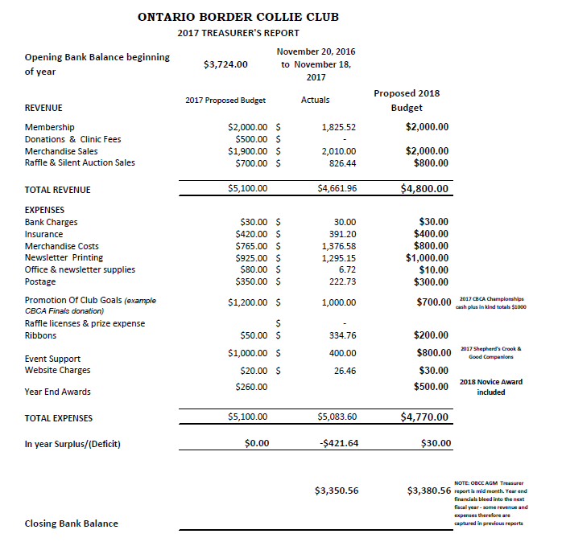
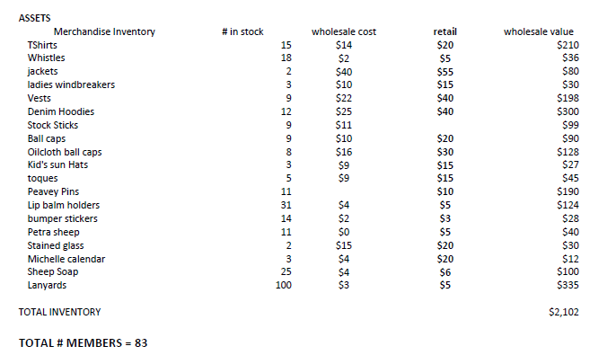
Ribbons are at Cynthia’s we should be OK for the beginning
    - TO DO -
      - Cynthia to count

Other
- Cynthia to mail out the plaques this week. Used our logo on the plaques this year
- Cynthia will bring the remaining trophies to the March Arena Trial
- Cynthia asks that the Board think of any other goals that we want to achieve for the year to discuss at the next meeting
  - Something for Novice? Open? Have more trials?

Next meeting:
- Next meeting will be Tuesday March 20, 2017 @ 6:30pm.
  - TO DO – Tracy to send the meeting

Tracy moved to adjourn. Meeting adjourned at 7:53pm.

